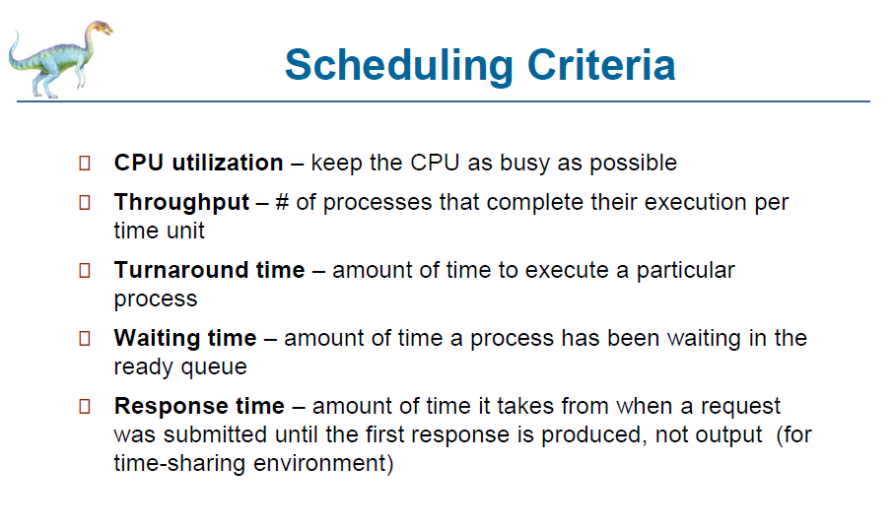

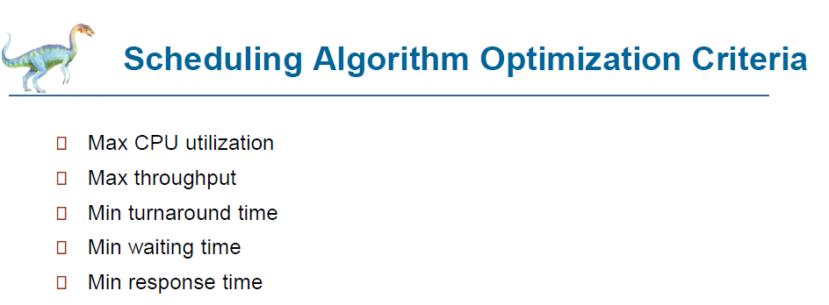

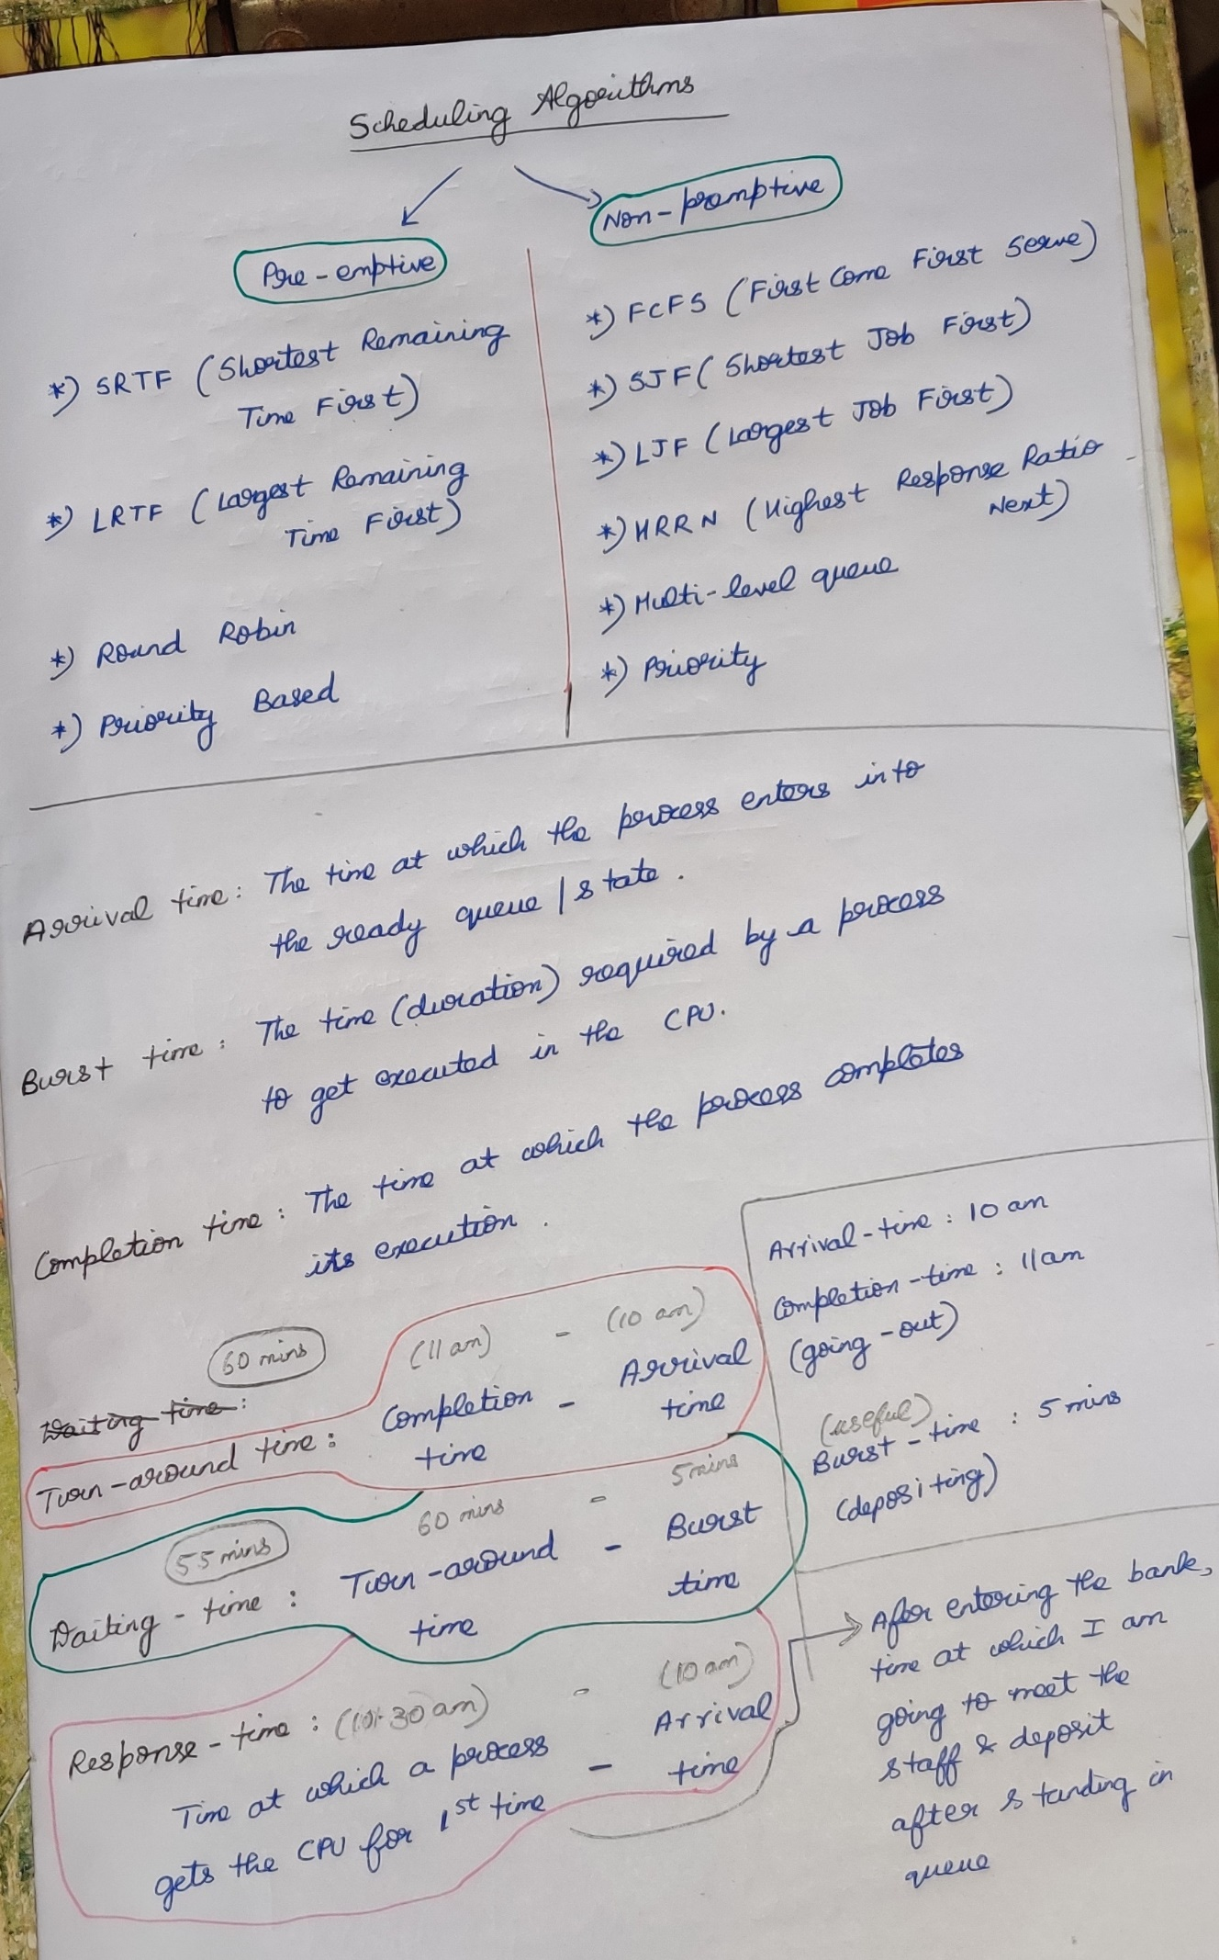

1. **First-Come First Serve Scheduling Algorithm**

**{Criteria : Arrival time} {Mode : Non-premptive}**

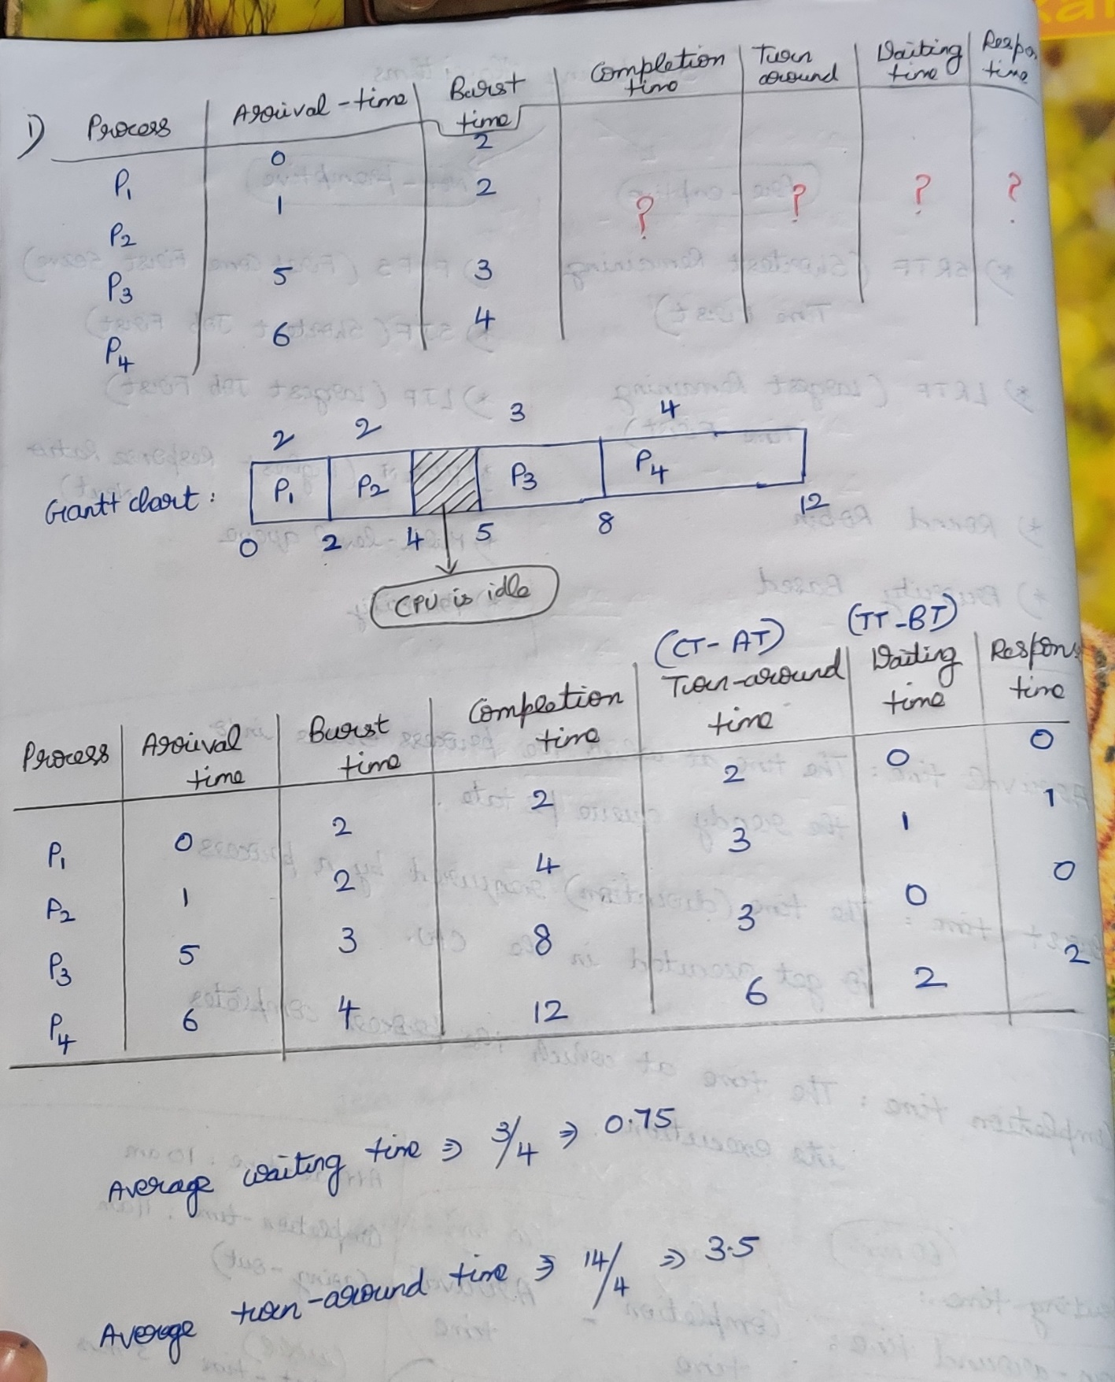

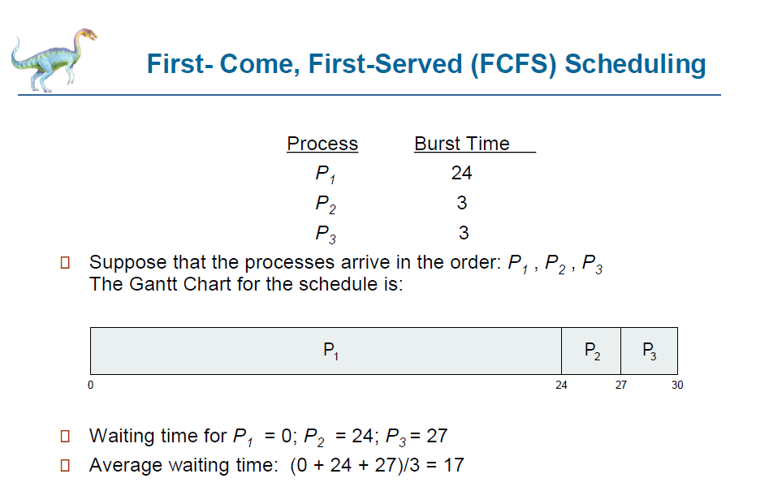

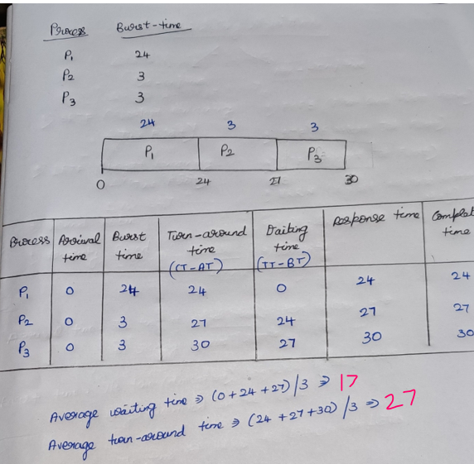



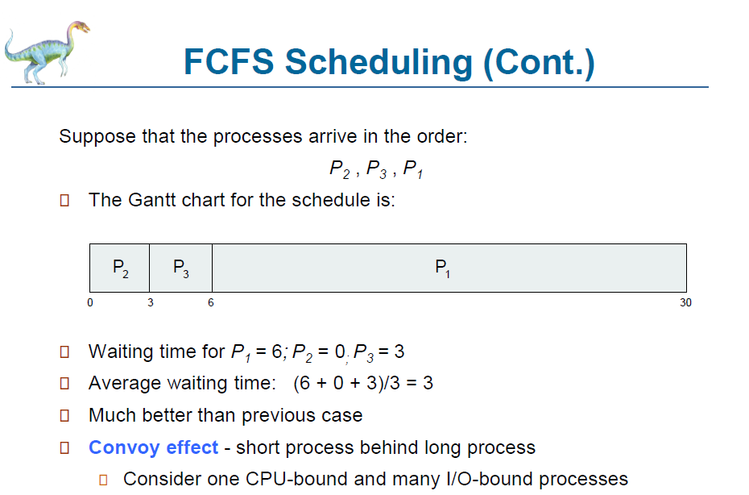



1. **Short Job First (SJF) Scheduling Algorithm**

**{ Criteria : Burst time } {Mode : Non Pre-emptive}**

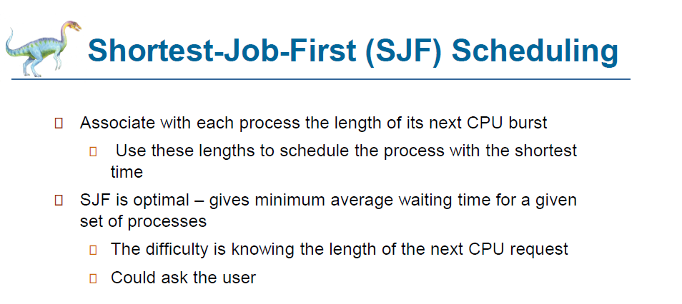

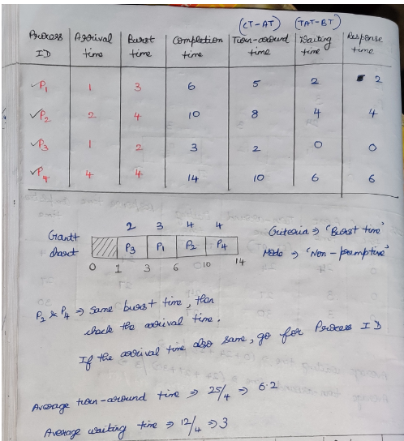



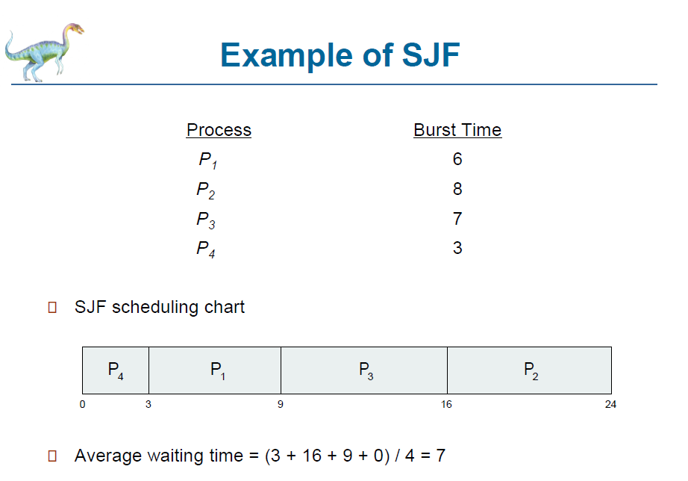

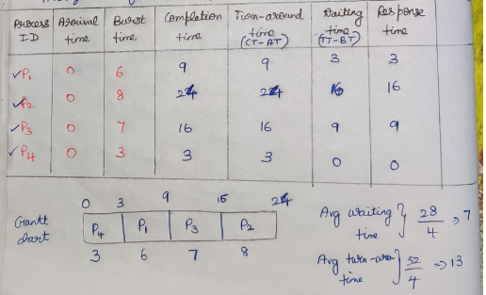

1. **Priority Scheduling Algorithm**

**{ Criteria : Priority } {Mode : Non Pre-emptive}**

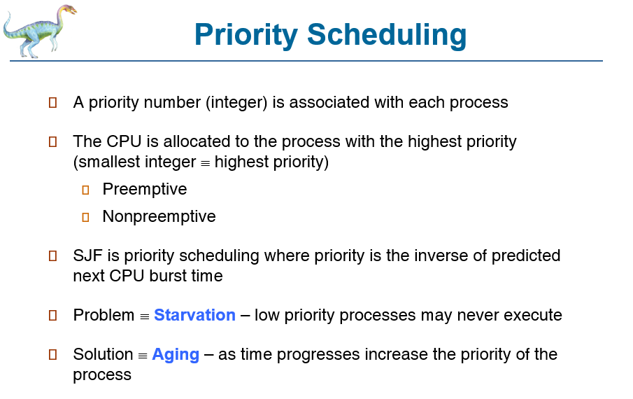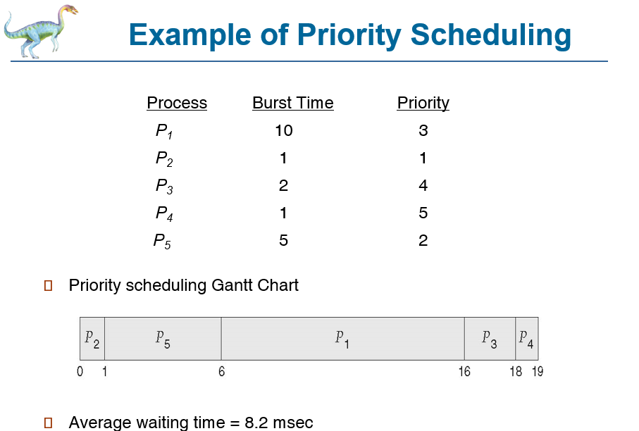

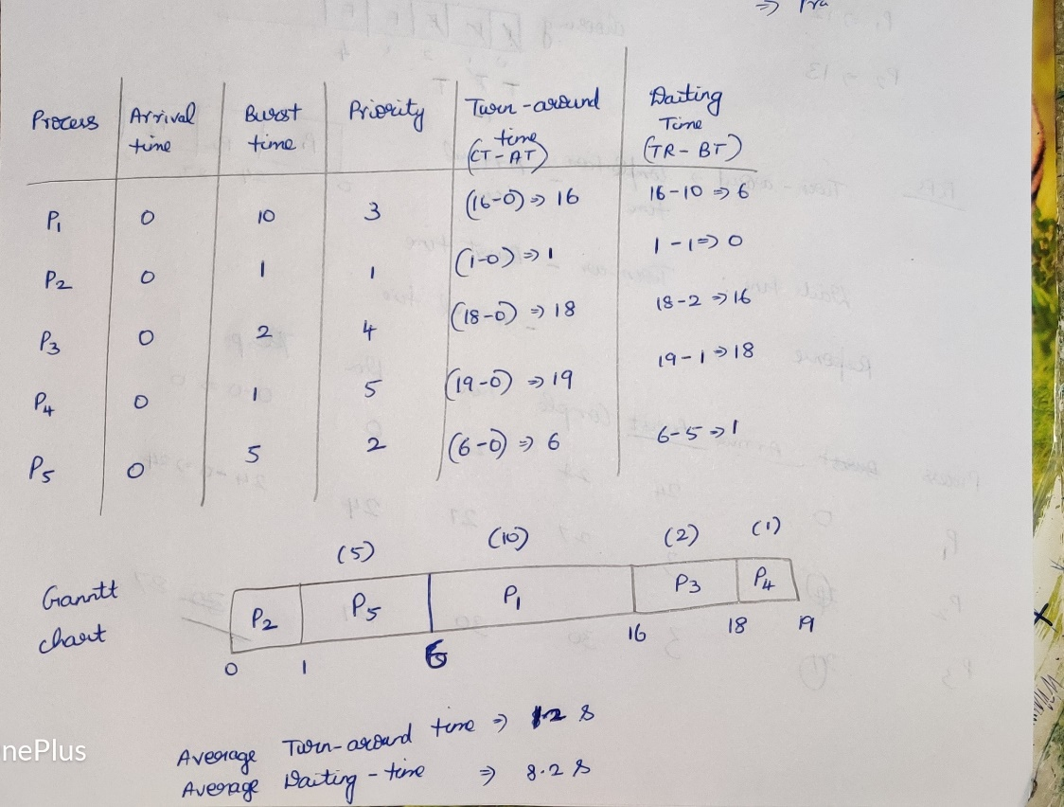

1. **Priority Scheduling Algorithm**

**{ Criteria : Priority } {Mode : Pre-emptive}**

**Question**

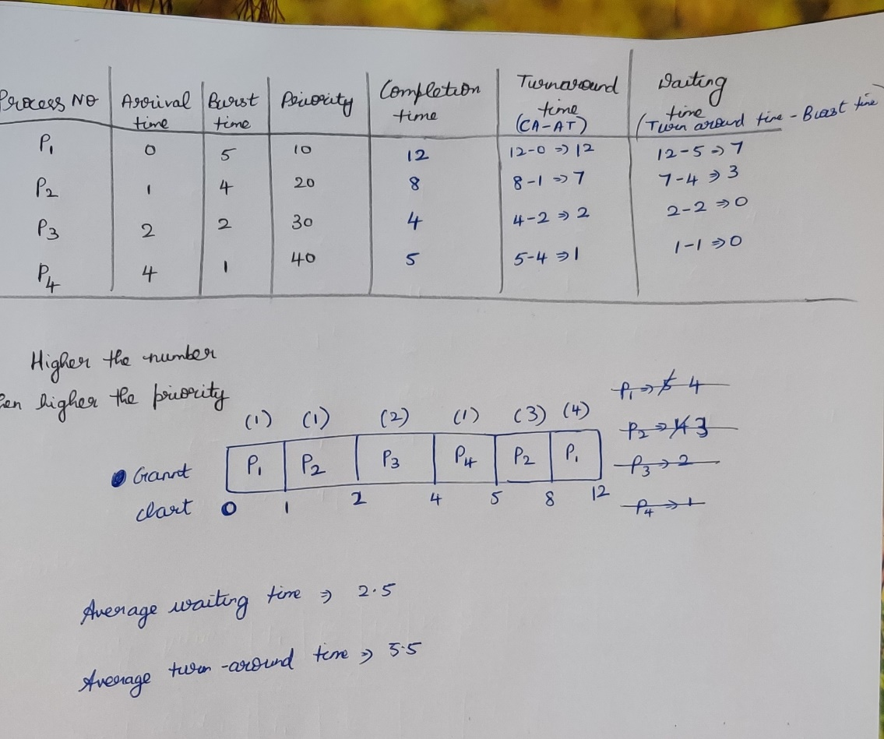

**Question**

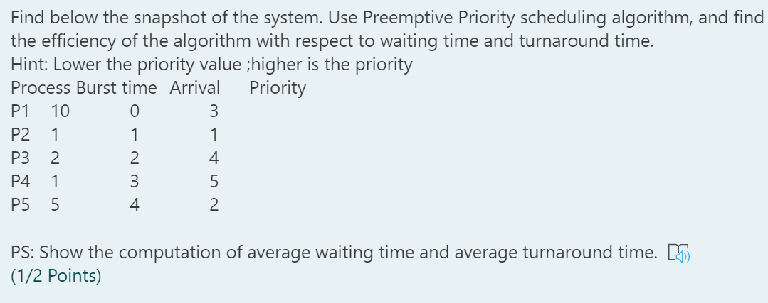

**Question**

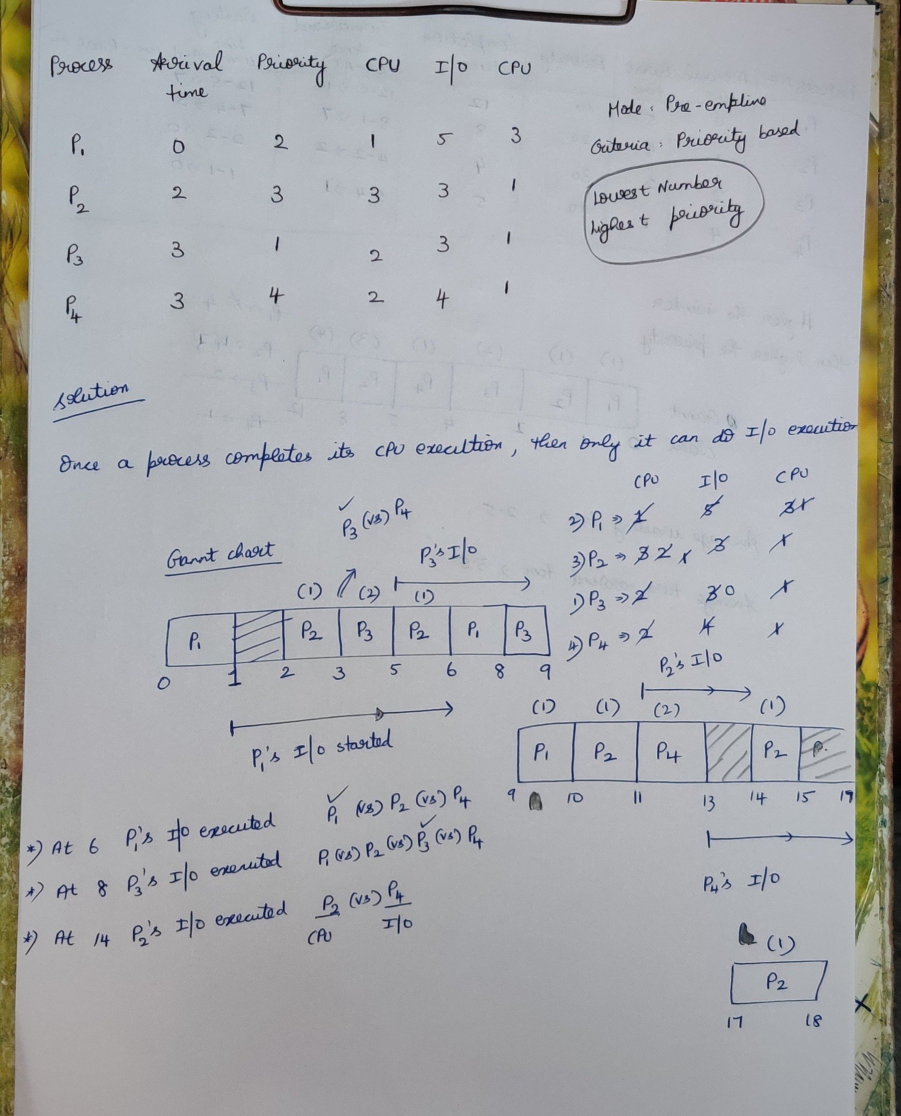

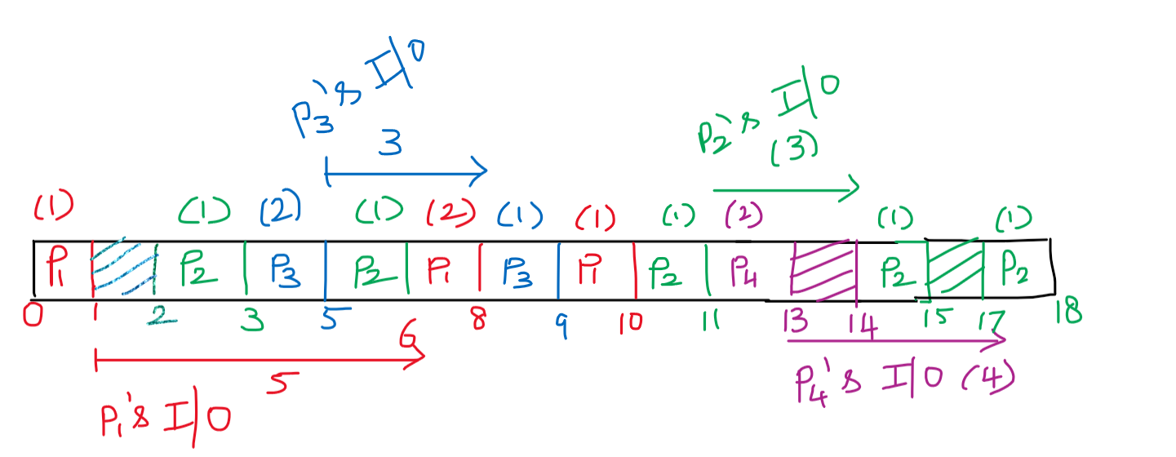

**Question**

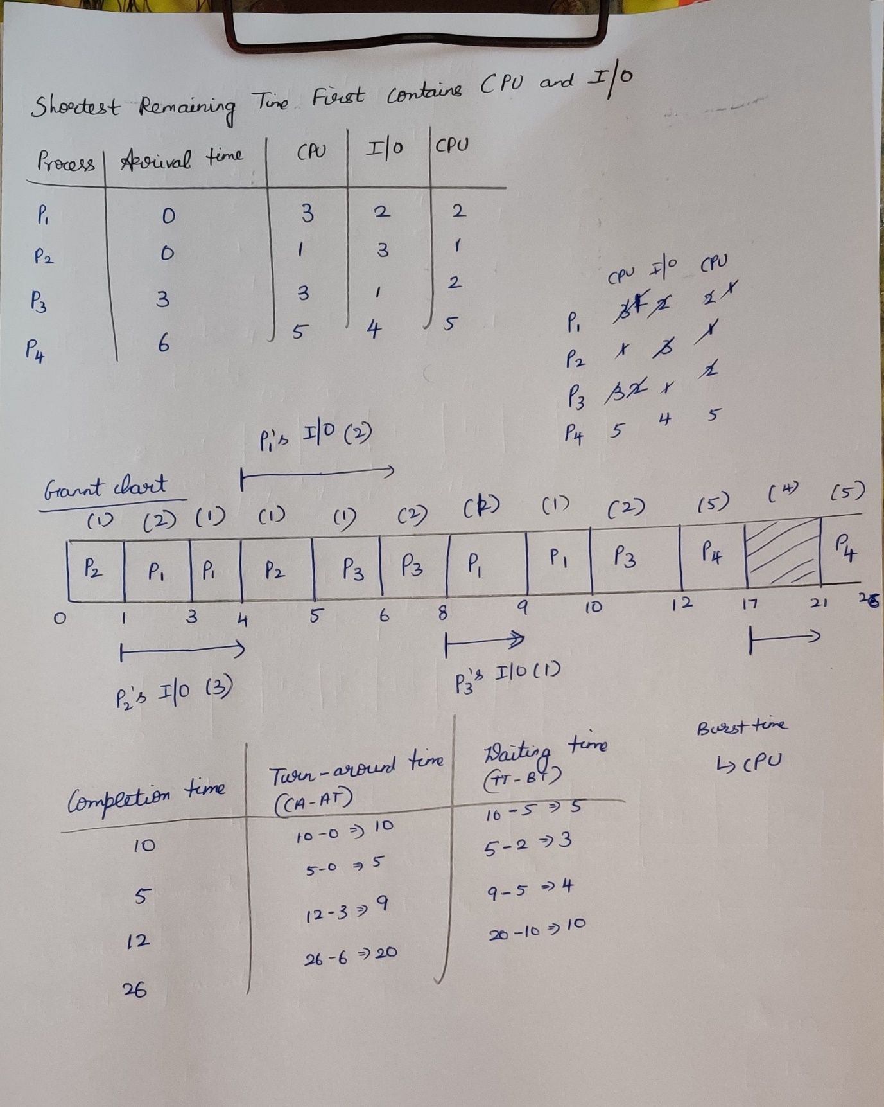

1. **Round Robin Scheduling Algorithm**

**{ Criteria : Time quantum } {Mode : Pre-emptive}**

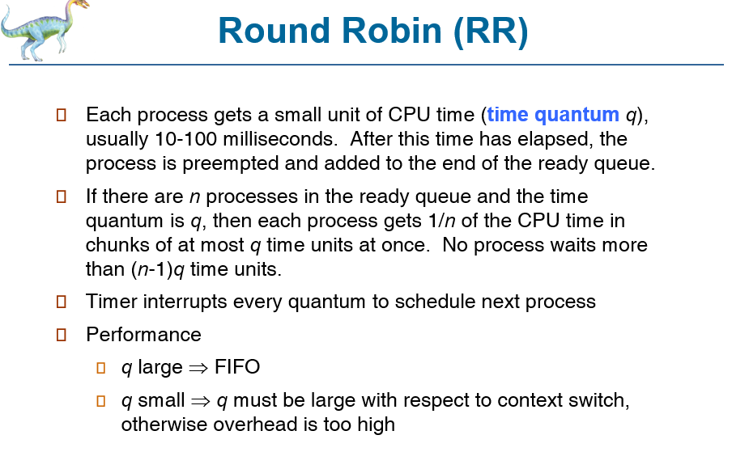

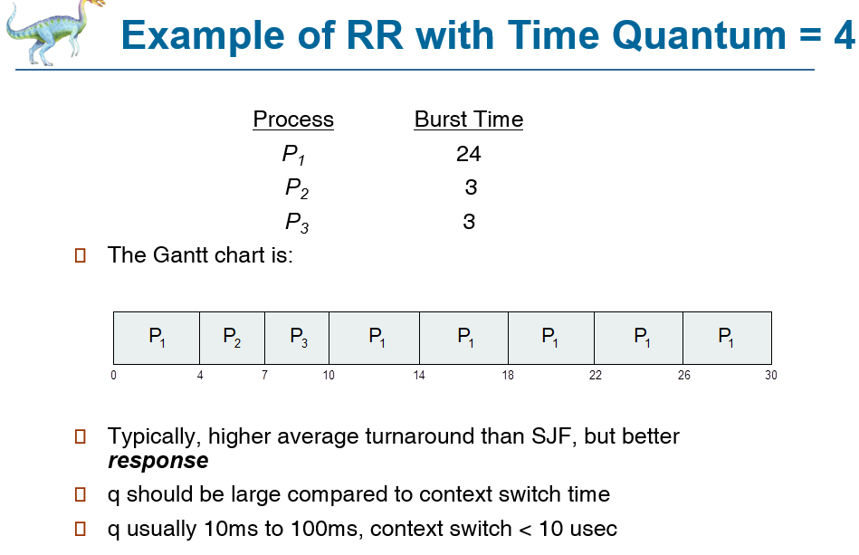

**Question**

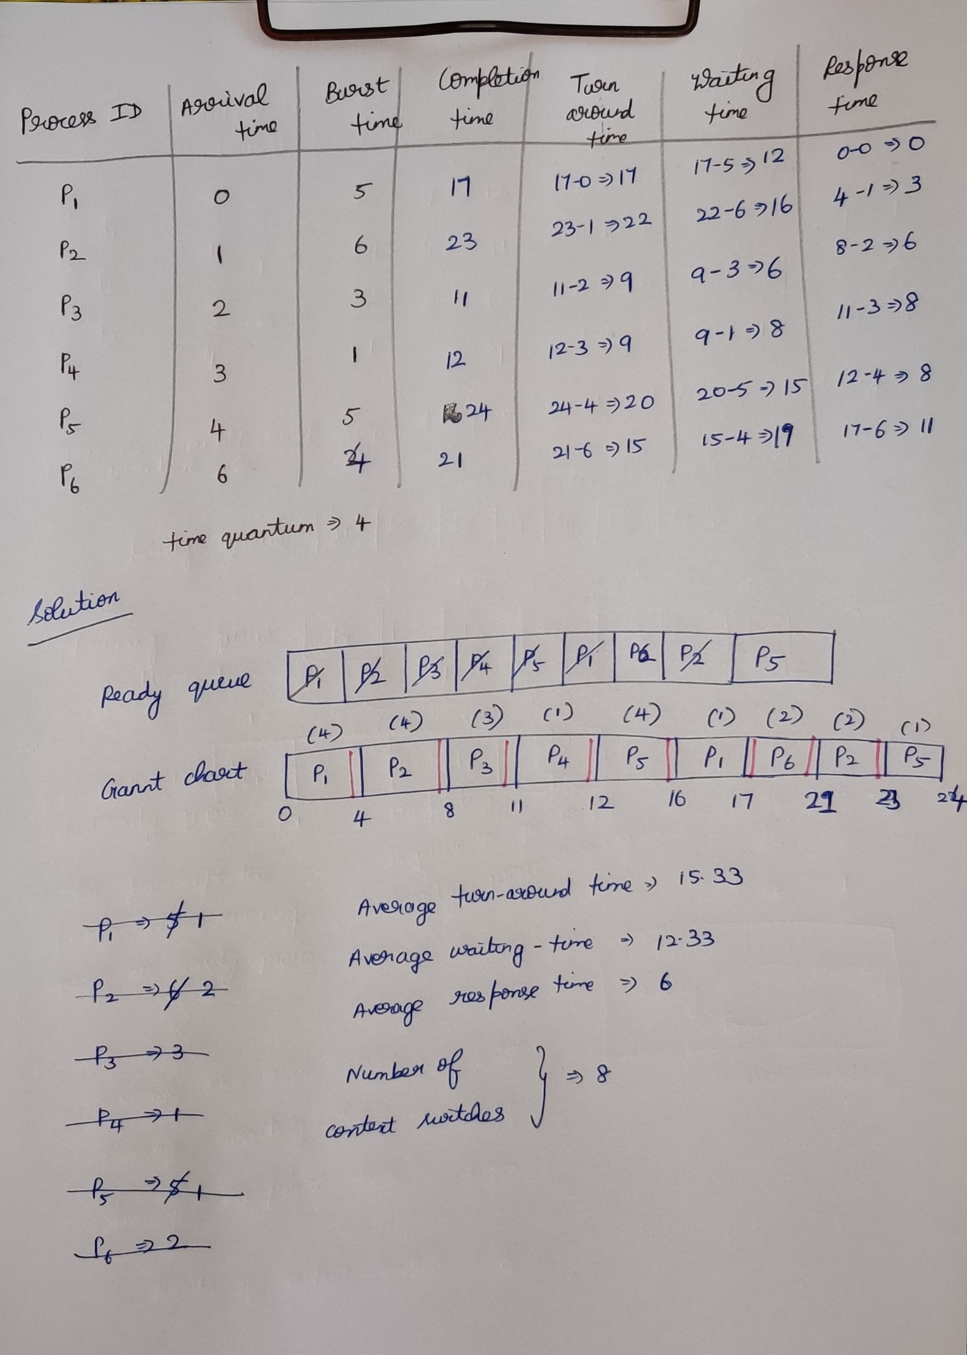

**Question**

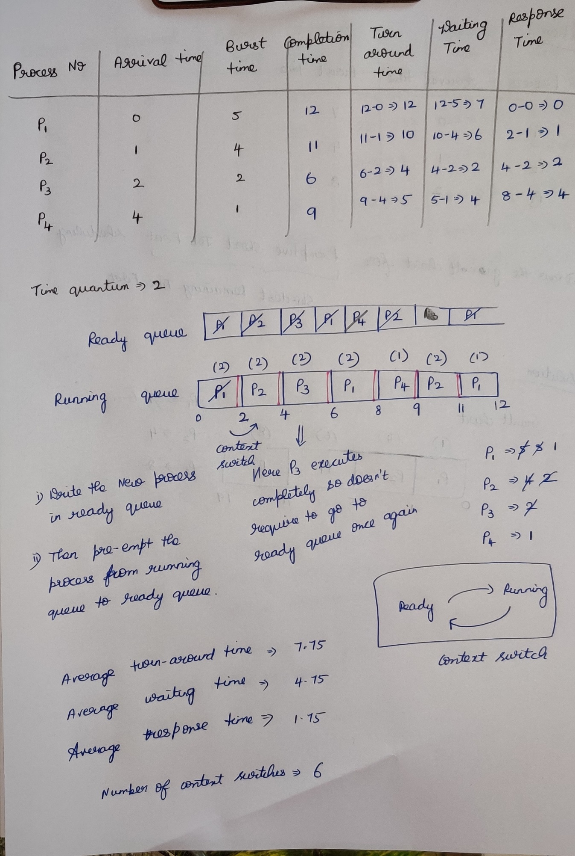

**6)Shortest Remaining Time First Scheduling Algorithm**

**{ Criteria : Burst-time } { Mode : Pre-emptive }**

**Question**

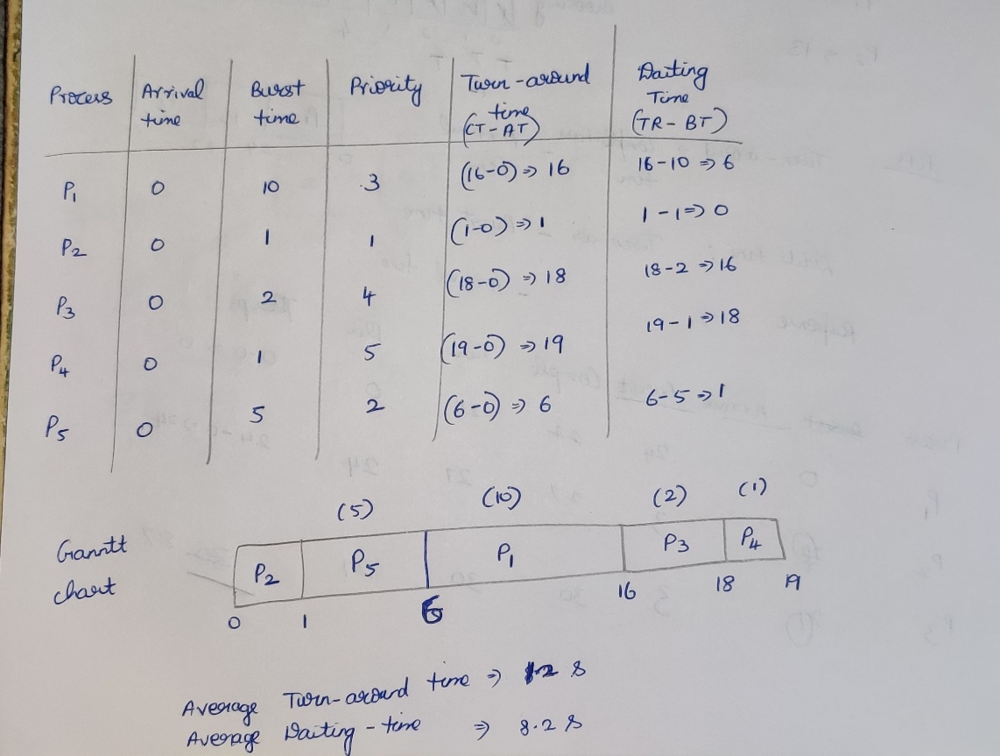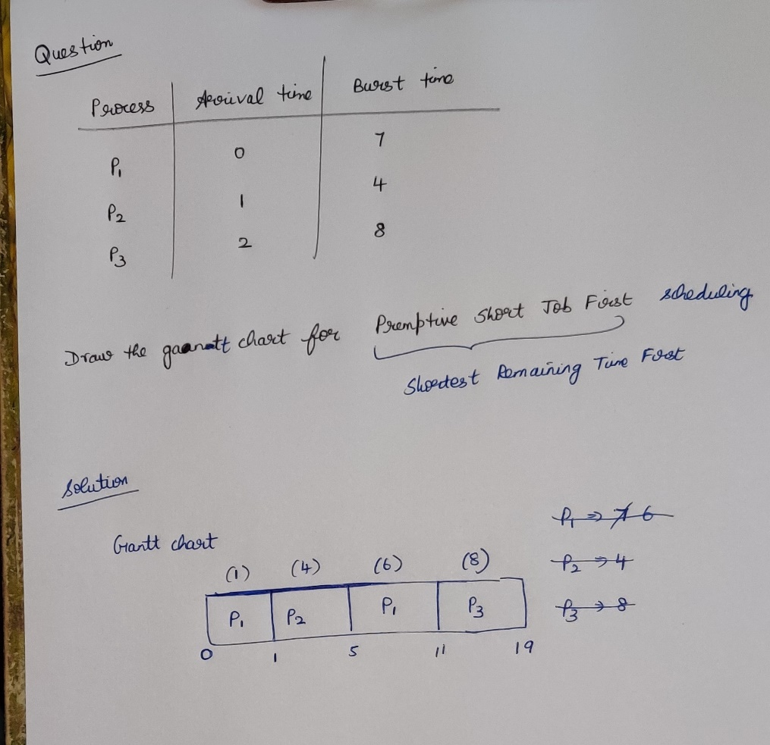

**Question**

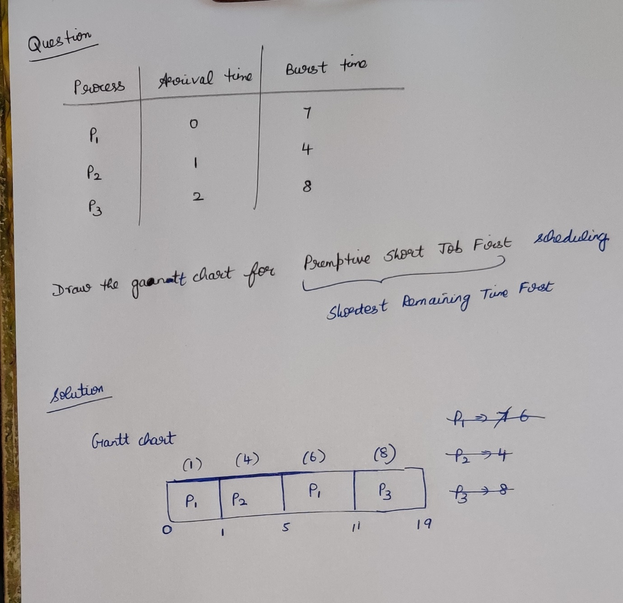

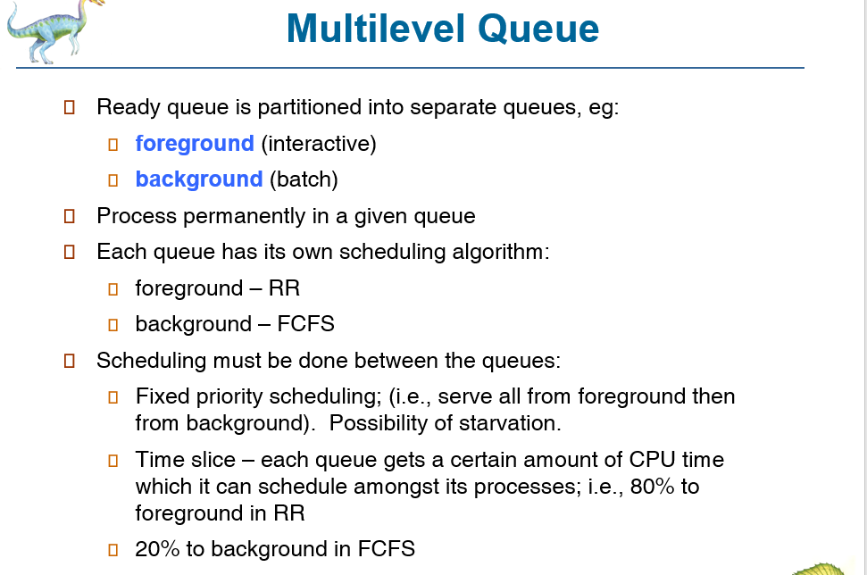

Q1 = Foreground process 🡪 User interactive (requires more response time) [Less waiting time]

Q2 = Background process 🡪 Happens at the backend (requires less response time) [ More waiting time]

Foreground process will be given the higher priority than background process .

Q2 will execute only if Q1 is empty. But this is not good, since Q2 waits for a very long time.

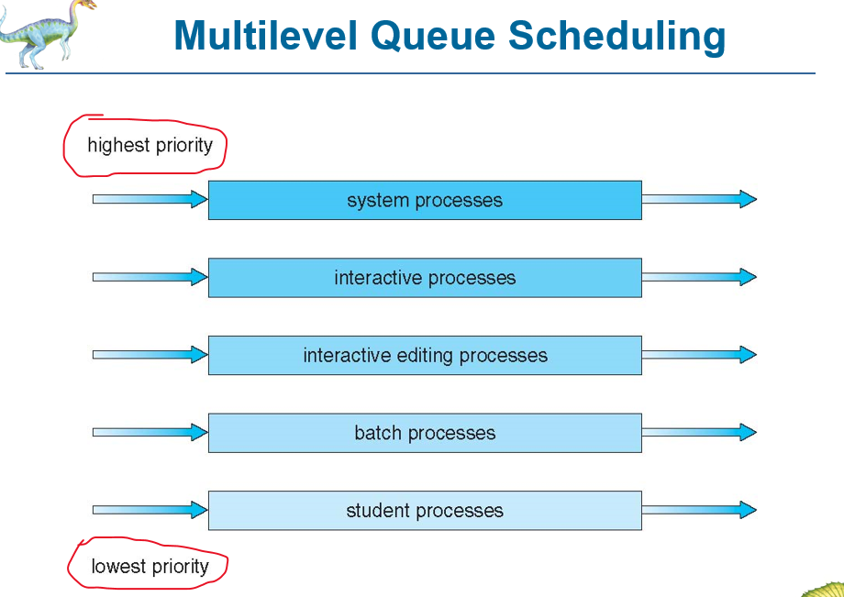

Starvation is the main problem in the multi-level queue, to give equal priorities to all the process according to their schedule multi-level feedback queue comes into the picture.

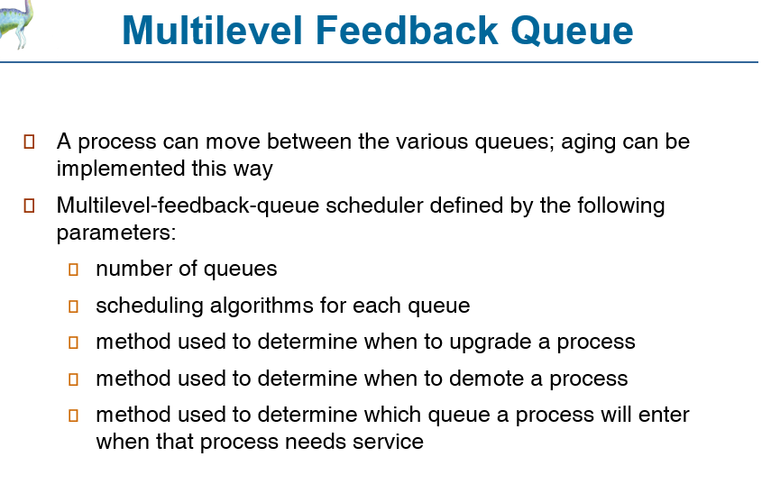

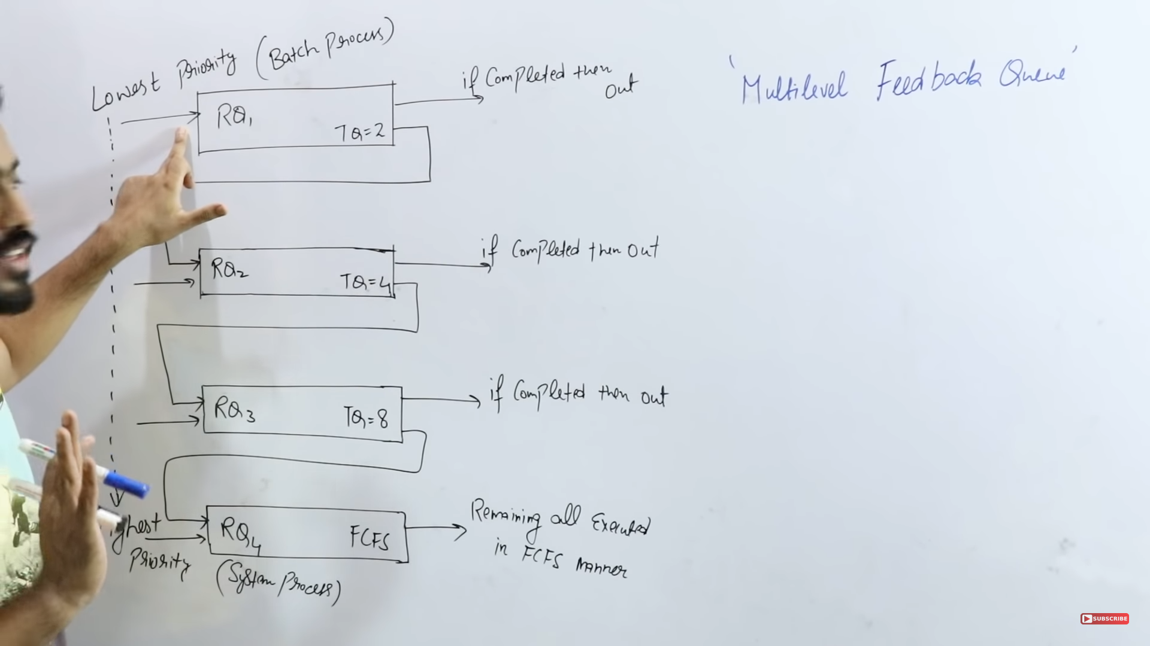

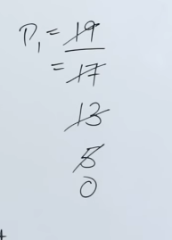

Higher priority process will come and execute without any starvation. It is designed only to give the lowest priority process to get some chance to execute in-order to avoid starvation.

**Question**

